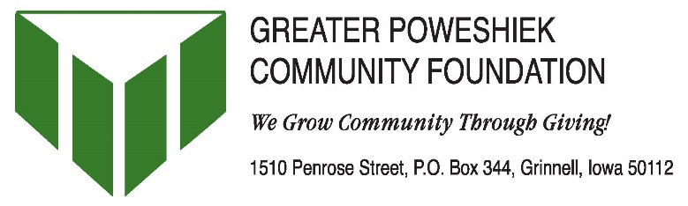
Nomination Form
Nomination Deadline: August 31st, 2016
Event Date: October 8th, 2016
Place: Grinnell College Golf Course
933 13th Avenue, Grinnell

The Spirit of Giving Awards provides an opportunity for the Poweshiek County community to publicly recognize those individuals, businesses and foundations that embody the philanthropic spirit of our county.

NOMINATION CRITERIA
- Who may submit a nomination? Any resident or organization that is located in or provides services to Poweshiek County.
- Nominations from any agency or organization are limited to one nominee per category.
- All individual nominees must be residents of Poweshiek County.

AWARD CATEGORY (please check only one)
☐ Business Partner of the Year Award- honors a business that fosters charitable giving by promoting and encouraging volunteerism and collaboration. The recipient has either partnered/collaborated with a non-profit in a creative way or supported non-profits in the community with a creative incentive program and is dedicated to giving back to the County in a significant manner.
☐ Connie Marshall Spirit of Giving Award- celebrates an individual or couple with a lifetime of service to others- through individual endeavors and through overall community involvement- a gift that spans a lifetime.
☐ Mentoring Award- recognizes an individual that has served as a mentor in the community and has made meaningful contributions to the quality of life in the county.
☐ Youth Spirit Award- celebrates a young adult (under 25 years) who has demonstrated exceptional leadership in promoting volunteerism in the community. The award can be earned for a single act of volunteerism or a number of volunteer efforts.

NOMINEE:
Name/Title of Nominee:
Nominee’s Company/Organization (if applicable):
Mailing Address:
City: Zip:
Phone: Fax: email:

NOMINATED BY:
Name/Title of Nominator:
Organization: email:
Phone: Fax:
Mailing Address:
City: Zip:
Your relationship to Nominee :

Nominator Signature
(continued on back page)
NOMINATION NARRATIVE:
Please respond to the following items.

1. What are the nominee’s specific achievements in philanthropy?

2. What impact has the nominee had on volunteerism, financial contributions and the community?

3. What leadership qualities does the nominee possess that promote the spirit of giving and volunteerism?

4. Please address any other criteria listed for the nominee’s award category.

5. (Optional but greatly appreciated) Is there a particular story that highlights the nominee’s accomplishments or his/her attitude toward giving?

INSTRUCTIONS:

- Type your responses on no more than two pages.
- If nominating in more than one category, a separate nomination form must be attached to each narrative.
- Do not submit nominee’s resume.
- Attach nomination narrative to first page of nomination form and submit together.

Completed nomination forms must be received or postmarked by August 31, 2016.

Return forms to the Greater Poweshiek Community Foundation by mail, fax or email.
Mailing address: Greater Poweshiek Community Foundation
PO Box 344
Grinnell, IA 50112

Fax: (641) 641-5590
Email: Nicole Brua-Behrens nicole@greaterpcf.org

Receipt of nomination forms will be acknowledged by email. Contact GPCF immediately if a nomination submission has not been acknowledged.

If you have questions concerning the nomination form or process, contact Nicole Brua-Behrens at (641) 236-5518 x222.

